

Promotional Examination 2 2010

Pre-university 2

H1 CHEMISTRY 8872
PAPER 1 8872 / 1

Thursday 23 September 2010 50 m

Additional materials:
OMR
Data Booklet

INSTRUCTIONS TO CANDIDATES

1. Do not turn over this question paper until you are told to do so.

2. Write your name, class and index number in the spaces provided at the top of this page and on the OMR provided.

3. Answer ALL questions and shade the correct answers on the OMR provided.

4. Hand in the question paper and the OMR separately.

FOR EXAMINER’S USE
Section | Total
Marks | 30

INFORMATION FOR CANDIDATES

Marks will not be deducted for wrong answers; your total score on this test will be the number of correct answers given.

Section A

For each question there are four possible answers, A, B, C and D. Choose the one you consider to be correct.

1 | Which of the following contains one mole of the stated particles?
 | A |  |  | Hydrogen atoms in 2 g of hydrogen gas
 | B |  |  | Hydrogen atoms in 22.4 dm³ of methane gas at s.t.p.
 | C |  |  | Chlorine molecules in 22.4 dm³ of chlorine gas at r.t.p.
# | D |  |  | Aqueous chloride ions in a 2 dm³ of 0.50 mol dm⁻³ NaCl solution.
2 | Carbon disulphide vapour was burnt in oxygen according to the equation:  CS₂(g) + 3O₂(g) → CO₂(g) + 2SO₂(g)  20 cm³ of carbon disulphide was burnt in 80 cm³ of oxygen. Upon cooling, the mixture of gases was treated with an excess of aqueous sodium hydroxide and the volume of gas was again measured. All measurements were made at the same temperature and pressure.  What was the final measurement of the volume of gas that was left behind?
 | A |  |  | 50 cm³
 | B |  |  | 40 cm³
# | C |  |  | 20 cm³
 | D |  |  | 10 cm³
3 | The standard enthalpy of formation of carbon dioxide and water are -394 kJ mol⁻¹ and -286 kJ mol⁻¹respectively. If the standard enthalpy of combustion of propyne, C₃H₄ is -1938 kJ mol⁻¹, calculate the standard enthalpy of formation for propyne.
 | A |  |  | +1258 kJ mol⁻¹
# | B |  |  | +184 kJ mol⁻¹
 | C |  |  | -184 kJ mol⁻¹
 | D |  |  | -680 kJ mol⁻¹
4 | A chemist discovered that an element N forms N²⁺ ions with the electronic configuration 1s² 2s² 2p⁶ 3s² 3p⁶ 3d⁸. Element N has a relative atomic mass of 2y+5, with y representing the proton number. How many neutrons are present in an atom N.
 | A |  |  | 28
 | B |  |  | 30
 | C |  |  | 32
# | D |  |  | 33
5 | What pair of compound has the same molecular shape?
# | A |  |  | AlCl₃ and BCl₃
 | B |  |  | AlCl₃ and PCl₃
 | C |  |  | BF₃ and NH₃
 | D |  |  | BeCl₂ and H₂O
6 | The rate of removal of the pain-killing drug paracetamol from the body is a first order reaction with a rate constant, k = 0.26 h⁻¹. How long will it take to remove 75% of the  paracetamol that a patient consumes?
 | A |  |  | 2.3 h
 | B |  |  | 2.7 h
# | C |  |  | 5.3 h
 | D |  |  | 8.0 h
7 | In an aqueous solution at 25ºC, the [OH⁻] is 6.0 x 10⁻⁹ mol dm⁻³. The given K_{w} is 1.0 x 10⁻¹⁴ mol² dm⁻¹⁴. What is the pH of the solution?
 | A |  |  | 6.00
 | B |  |  | 7.00
# | C |  |  | 5.77
 | D |  |  | 4.22
8 | Ammonia is produced from hydrogen and nitrogen, according to the equation:  N₂ + 3H₂ 2NH₃ ΔH = -ve  The graph shows the yield of ammonia produced at 200°C and 100 kPa.  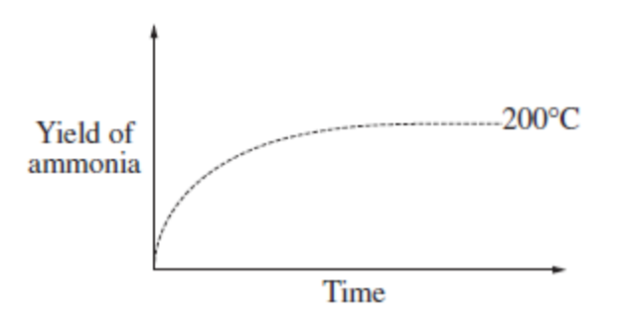  Which of the following graphs show the correct yield of ammonia at 400°C and 100 kPa?
 | A |  |  | 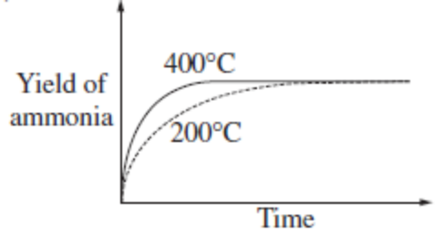
 | B |  |  | 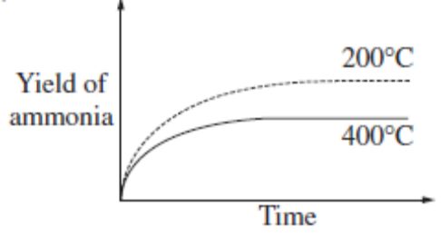
# | C |  |  | 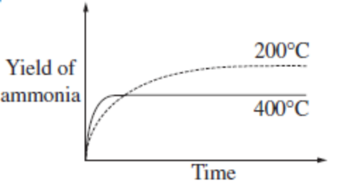
 | D |  |  | 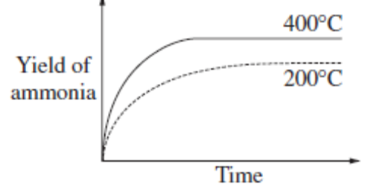
9 | The energy profile for a reversible reaction is shown below.  Energy  Reaction pathway  Reactant A  Product B  x  y
 | A | The backward reaction is exothermic.
 | B | The activation energy of the forward reaction is y – x.
# | C | The activation energy of the backward reaction is x + y
 | D | The enthalpy change of the forward reaction is x+y.
10 | Which of following oxides will produce a solution with the lowest pH when treated with water?
 | A | SiO₂
# | B | SO₂
 | C | MgO
 | D | Na₂O
11 | In which of the following pairs is the difference in melting point the largest?
 | A | Sodium and magnesium
 | B | Magnesium and silicon
 | C | Chlorine and argon
# | D | Silicon and argon
12 | The following graph shows how a property of the elements Na to C/ varies with proton number.  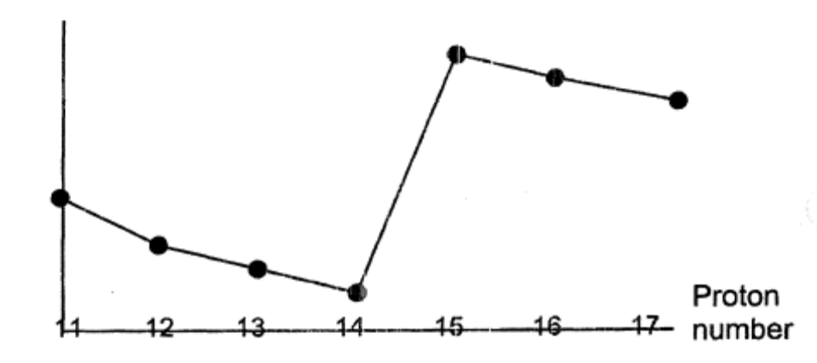  What is the property?
 | A | Electronegativity
 | B | First ionisation energy
# | C | Ionic radius
 | D | Melting point
13 | As the number of carbon atoms in a homologous series of alkane molecules increases, for which property of the alkanes does the numerical value decrease?
 | A |  |  | Density
 | B |  |  | Enthalpy change of vaporization
 | C |  |  | Number of isomers
# | D |  |  | Vapour pressure.
14 | Which of the following is the main product when 2-methylbutan-2-ol reacts with concentrated H₂SO₄?
 | A |  | pent-2-ene
# | B |  | 2-methylbut-2-ene
 | C |  | 2,2-dimethylpropene
 | D |  | Propanone
15 | When chlorine is passed through ethanoic acid in the presence of UV light, the organic compound formed is likely to be
 | A |  |  | CH₃COCl
 | B |  |  | ClCH₂CHO
 | C |  |  | ClCH₂CH₂OH
# | D |  |  | ClCH₂COOH
16 | When propanone is heated with iodine and aqueous alkali, 3.94g of triiodomethane is formed. What is the mass of propanone heated?
 | A |  |  | 0.16g
# | B |  |  | 0.58g
 | C |  |  | 3.98g
 | D |  |  | 4.12g
17 | The oxidation of an alkene X produces a type of diol. A continuous oxidation process will produce a diketone. What could X be?
 | A | (CH₃)₂C=C(CH₃)₂
 | B | CH₃CH=C(CH₃)₂
 | C | (CH₃)₂CHCH=CH₂
# | D | CH₃CH=CHCH₃
18 | When a student tested samples of insecticide extracts with 2,4-dinitrophenylhydrazine, colourful crystals with high melting point were obtained. Which compound most probably reacted in the extract to give such a result?
 | A | CH₃CH₂OH
# | B | CH₃CHO
 | C | CH₃COOH
 | D | CH₃CH₃
19 | The graph shows the mass and amount of carbon, fluorine and chlorine atoms in one mole of a compound.  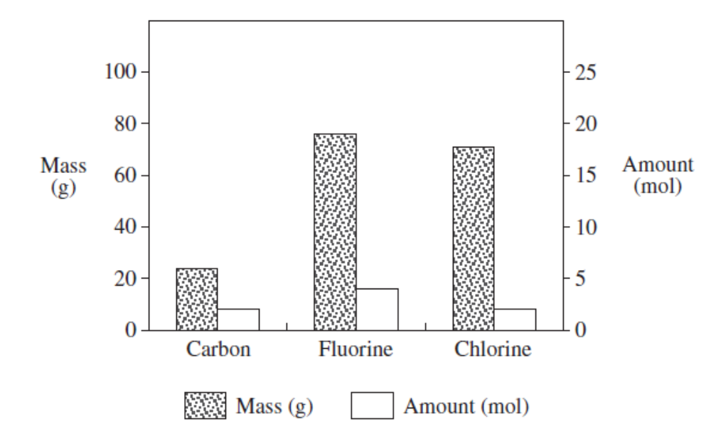  What is the molecular formula for this compound?
 | A | CF₂Cl
 | B | CF₂Cl₂
 | C | C₂F₃Cl₃
# | D | C₂F₄Cl₂
20 | The rate of reaction between propanone and iodine using acid as a catalyst is determined using spectrophotometer in the laboratories. In this reaction, why is the concentration of propanone kept high?
 | A | It acts as a buffer solution.
 | B | It increases the rate of the reaction.
 | C | It maintains the consistency of the rate of the reaction.
# | D | It ensures that the concentration of propanone is kept a constant.

Section B

For each of the questions in this section, one or more of the three numbered statements
1 to 3 may be correct.

Decide whether each of the statements is or is not correct.

The responses A to D should be selected on the basis of

A | B | C | D
1, 2 and 3 are correct | 1 and 2 only are correct | 2 and 3 only are correct | 1 only is correct

No other combination of statements is used as a correct response.

21 | Boron nitride has a structure that is similar to graphite.  Which of the following characteristic/s is/are shown by this compound?
# | 1 | It is a lubricant.
 | 2 | It is very hard.
 | 3 | It is transparent at standard conditions.
22 | Consider the reaction PCI₅(g) PCI₃(g) + CI₂(g)  For such a system, of a total volume 1.0 dm³ and a total pressure of 202.6 kPa, at equilibrium, the percentage dissociation of PCI₅(g) at 100°C is 28 % and that at 220°C is 78 %.
# | 1 | The dissociation of PCI₅(g) is an endothermic reaction.
# | 2 | The presence of a catalyst will allow dynamic equilibrium to be achieved much faster.
# | 3 | An increase in the concentration of PCI₅(g) will cause the rate of the forward reaction to increase.
23 | The following reaction is believed to be of first order.  X → products  In an experiment, [X], the concentration of X, varied with time as shown in the graph.  What can the graph be used to for?  [X]  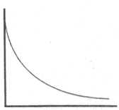time
# | 1 | To determine the rate of reaction at any given instant.
# | 2 | To determine if the reaction is of first order throughout.
# | 3 | To determine half life of the reaction.
24 | In which of the following process/es is/are energy being absorbed?
 | 1 | F(g) + e → F⁻(g)
# | 2 | Na(g) → Na⁺(g) + e
# | 3 | NaCl(s) → Na⁺(g) + Cl⁻(g)
25 | Which of the statement/s is/are true concerning a metallic bond?
 | 1 | Strong electrostatic forces of attraction exist between oppositely charged ions.
# | 2 | Lattice of positive ions is present in a metallic bond.
# | 3 | The strength of the metallic bond increases when the number of delocalized electrons increases.
26 | Which of the following solids is an example of a substance with a macromolecular structure?
# | 1 | Diamond
# | 2 | Silicon(IV) oxide
 | 3 | Silicon (IV) chloride
27 | Bromine that is dissolved in an inert solvent is added to hexane, benzene, hexene and methylbenzene in the absence of light. Which of the following pairs of compound will produce the same observation?
# | 1 | Hexane and benzene
 | 2 | Hexane and Hexene
 | 3 | Hexene and methylbenzene
28 | After an oil spill in the ocean, liquid hydrocarbon was found floating on the water surface. Which statements explain why liquid hydrocarbon is less dense than water causing it to float on the water?
# | 1 | There are only van der waal forces of attraction between the hydrocarbon molecules.
 | 2 | The hydrogen bonds between water molecules cause the water molecules to be closer.
 | 3 | Hydrocarbon molecules do not undergo hydration by the water molecules.
29 | The queen bee secretes a type of chemical substance that encourages the building of colony cells by the other ordinary bees. That chemical substance has the following molecular formula:  CH₃CO(CH₂)₅CH=CHCO₂H  Which statement/s is/are true about the compound above?
# | 1 | It can exist as a cis-trans isomer.
# | 2 | 1 mole of the compound reacts with Na to give 1 mole of H₂.
 | 3 | It provides a positive test with Fehling’s solution.
30 | Which of the following reagents, when added to the compound below, would show a colour change?  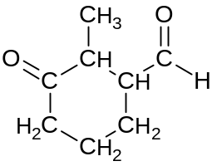
 | 1 | Hot aqueous alkaline iodine
# | 2 | Tollen’s reagent
# | 3 | Hot acidified potassium manganate (VII)

End of Paper

